St. Francis Institute of Technology, Mumbai-400 103.

**Department of Information Technology**

A.Y. 2023-2024

Class: SE-ITA/B, Semester: IV

Subject: **UNIX LAB**

**Experiment – 8: Shell script and sed programming.**

1. **Aim:** To study and implement shell script programming and sed. **2. Objectives:** 

● To understand shell script programming and sed.

● To develop sed shell scripts.

3. **Outcomes:** After study of this experiment, the student will be able to ● Develop shell scripts using sed.

4. **Prerequisite:** Knowledge of Shell scripts.

5. **Requirements:** Personal Computer, Ubuntu OS, Text Editor, LibreOffice.

**6. Pre-Experiment Exercise:**

**Brief Theory:**

**sed:**

sed is a **s**tream **ed**itor. A stream editor is used to perform basic text

transformations on an input stream (a file or input from a pipeline). While in some ways similar to an editor which permits scripted edits (such as ed), sed works by making only one pass over the input(s), and is consequently more efficient. But it is sed’s ability to filter text in a pipeline which particularly distinguishes it from other editors. With sed, we can edit complete files without actually having to open it.

sed uses instructions to act on text. An instruction combines an **address** for selecting lines, with an **action** to be taken on them.

**Syntax:**

sed options ‘address action’ file(s)

Addressing in sed is done in two ways:

● By one or two line numbers.

● By specifying a /-enclosed pattern which occurs in a line.

The action can either be a simple display or an editing function like insertion, deletion or substitution of text.

**Laboratory Exercise**

**A. Procedure**

1. Write a shell program to generate multiplication table of a number upto a given range.

2. Write a shell program to count the number of files in a directory. 3. Write a shell program using sed to perform line addressing.

4. Write a shell program using sed to perform context addressing.

5. Write a shell program using sed to perform substitution.

**B. Result/Program code Screenshots**

**7. Post-Experiments Exercise**

**A. Extended Theory:**

Nil

**B. Questions:**

1. Write a sed command to duplicate each line in a file in Unix.

**C. Conclusion:**

1. Write what was performed in the experiment.

2. Mention few applications of what was studied.

3. Write the significance of the topic studied in the experiment.

**D. References:** 

1. Yashwant Kanetkar, UNIX Shell Programming, BPB Publications. 2. Sumitabha Das, UNIX Concepts and Applications, 3rd Ed., Tata McGraw Hill. 3. <https://www.gnu.org/software/sed/manual/sed.html>.

**LAB-EXERCISE**  **RIYA INDAP,44**

1. Write a shell program to generate multiplication table of a number upto a given range.

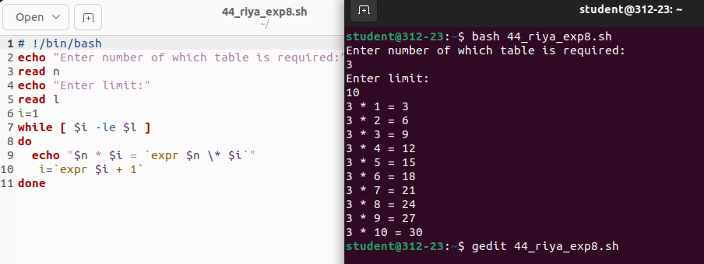

2. Write a shell program to count the number of files in a directory.

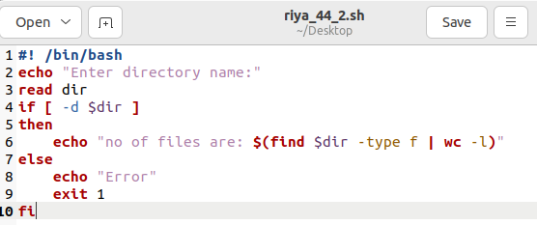

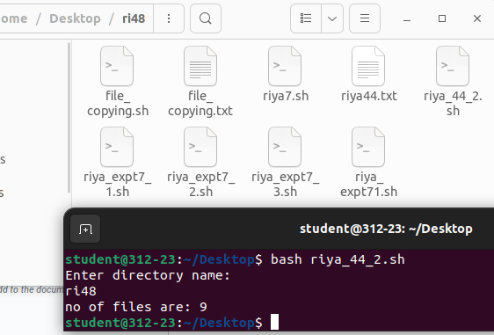

3. Write a shell program using sed to perform line addressing.

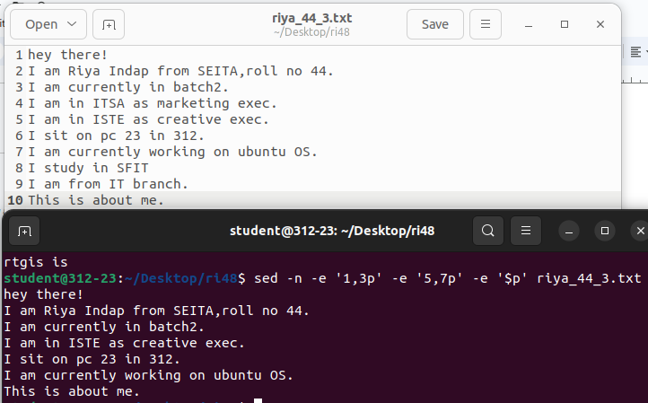

* 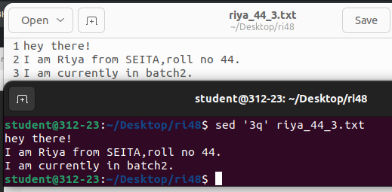
* 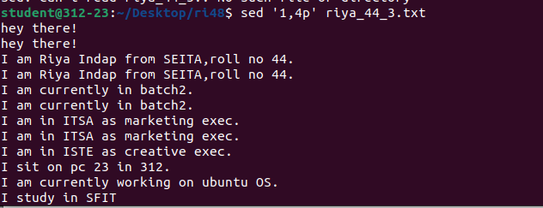
* 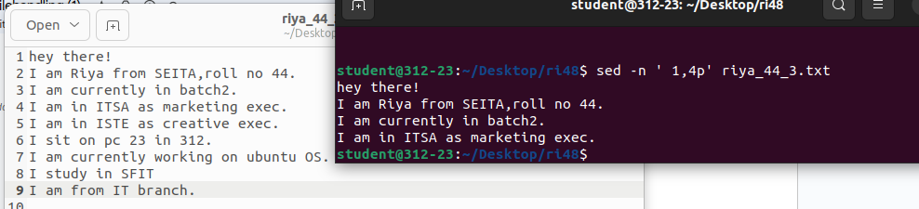
* 

4. Write a shell program using sed to perform context addressing.

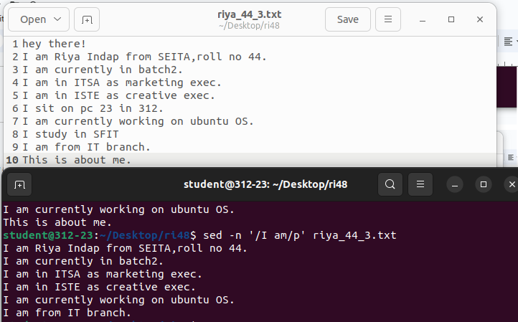

* 

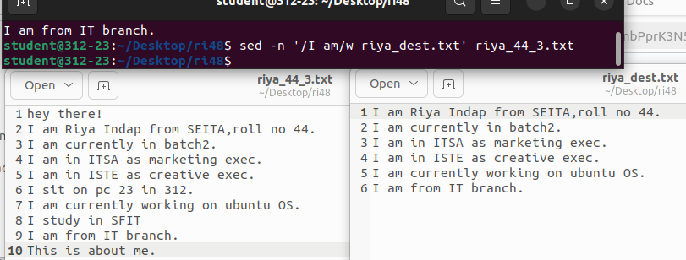

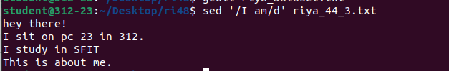

5. Write a shell program using sed to perform substitution.

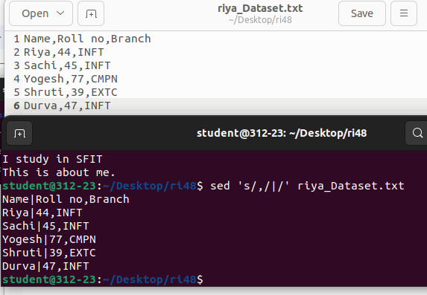

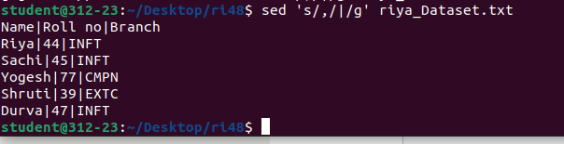

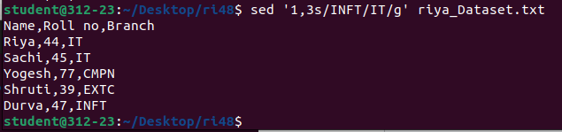

POST-EXPERIMENT

